Hawaii Quilt Guild Block of the Month (BOM) – May 2026
Irish Chain.
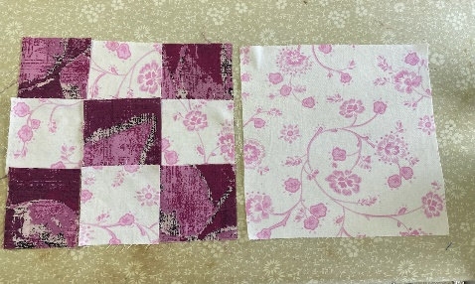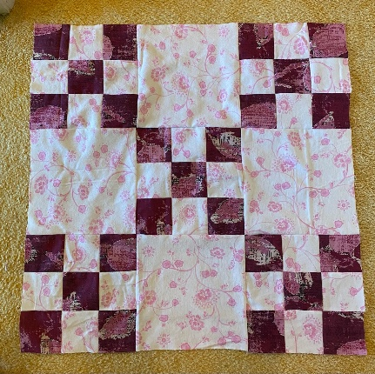
- The traditional block is actually two blocks with two fabrics to create the diagonal lines. From the dark fabric, cut five 3-1/2” squares. From the light fabric, cut four 3-1/2” squares and one 9-1/2” square. With the 3-1/2” squares, make a 9-patch block. It should measure 9-1/2” square. For your quilt, you will alternate between the 9-patch and 9-1/2” square.

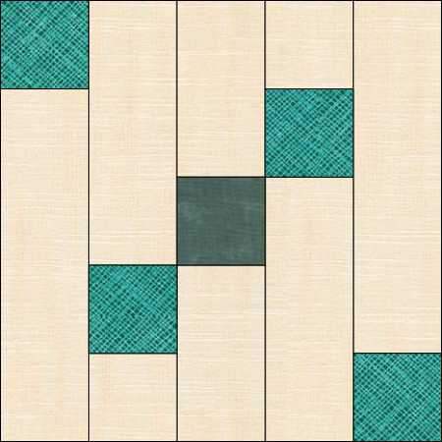
- For the Modern variation:
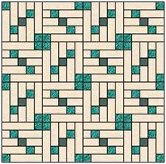
- Cutting instructions: You will need three fabrics. One background fabric, one contrasting fabric, and one focus fabric for the center of the block. From the background fabric cut two 2 1/4” squares; two 5 7/8” by 2 1/4” rectangles; two 4 1/8” by 2 ¼” rectangles; and two 7 3/4” by 2 1/4” rectangles. From the contrasting fabric cut four 2 1/4” squares. From the focus fabric cut one 2 1/4” square.

- Piecing instructions: You will piece five columns. Starting from the left, sew a contrasting square to the top of a 7 3/4” rectangle to form column A. Take a 5 7/8’ background rectangle and sew a 2 1/4 “contrasting square to the bottom. Then take a 2 14” square of background and add it to the bottom of the column to form Column B. Take two 4 1/8” rectangles and sew to the ends of the focus fabric square to form column C. The focus fabric will be in the center of Column C. Take a 5 7/8’ background rectangle and sew a 2 1/4 “contrasting square to the top. Then take a 2 14” square of background and add it to the top of the column to form Column D. Sew a contrasting square to the bottom of a 7 3/4” background fabric rectangle to form column E. Press the columns to the darker fabrics. Sew Column A to Column B and Column C to Column D. Sew Column E to Column D. Sew Column C to Column B. It is helpful to lay the columns out A to E before sewing to make sure the orientations are correct.

