Hawaii Quilt Guild Block of the Month (BOM – March 2026

Traditional – Friendship Star Block - makes 1- 9 1/2” block

Cutting Instructions: Cut 2 - 4” x 4” pieces of color 1 (focus fabric)
Cut 2 - 4” x 4” pieces of color 2 (background)
Cut 1 – 3- 1/2” x 3- 1/2” piece of color 1
Cut 4 – 3- 1/2” x 3- 1/2” pieces of color 2

Piecing Instructions: Make Half Square Triangles (HST) with the 4” squares: Draw a diagonal line on the backs of the lighter pair of 4” squares. Place 1 each - color 1 and color 2 with right sides together. With drawn line up, sew 1/4” inch on both sides of line. Cut on the drawn line. You now have 4 HSTs. Press HSTs open and trim to 3 1/2” squares.
Arrange 4 HSTs and 3-1/2” squares into a 9 patch as shown in Fig below. Be mindful of how the HST’s are set.
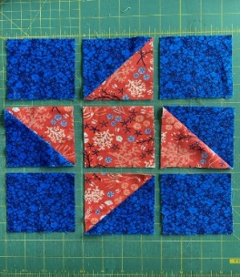

Modern Friendship Star Directions
Cutting Instructions: 4 squares 3.5” x 3.5” of background fabric (fabric A)
1 square 3.5” x 3.5” of center square material (fabric B)
2 squares 3 7/8” x 3 7/8 of fabric A – cut each square in half diagonally
1 square 4.25 x 4.25 of fabric B – cut it diagonally in both directions to get 4 triangles
1 square 4.25 x 4.25 of contrasting fabric (fabric C) – cut it diagonally to get 4 triangles

Piecing Instructions: Piece a fabric B triangle to a fabric C triangle to form a new half square triangle (see picture). Make sure you are piecing short sides together. Do the same with the remaining Fabric B and C triangles. You should have a total of 4 half square triangles. We will call these quarter square triangles.
Piece a fabric A half square triangle to a quarter square triangle to form a square (square D). Do the same for the remaining Fabric A and quarter square triangles. For the top and bottom rows, piece a Fabric A square to each side of a square D and press toward the D square. Refer to the picture below to make sure you will have a pinwheel effect. It is helpful to lay out the pieces before sewing the seams. For the middle row piece a square D to each side of the center square. Press toward the D squares. Piece together the rows, matching the seams.
 