BLOCK OF THE MONTH - Delectable Mountain Block
The block for March is Delectable Mountain. You will need to make two blocks to get the delectable mountain look. The instructions below will make two blocks.
Instructions:
- Cut two 10.5” squares of fabric. The fabrics should be contrasting.
- Make half square triangles (HST) the two at a time method. Place the two right sides together. Mark a diagonal line. Sew ¼” from the line on both sides. Cut on the diagonal line and press open. Trim to 9 ½ “ squares.
- Turn one block so that the diagonal runs in a different direction - see picture for orientation.
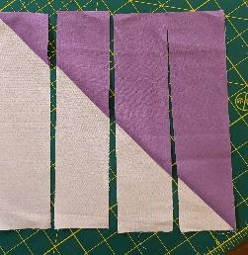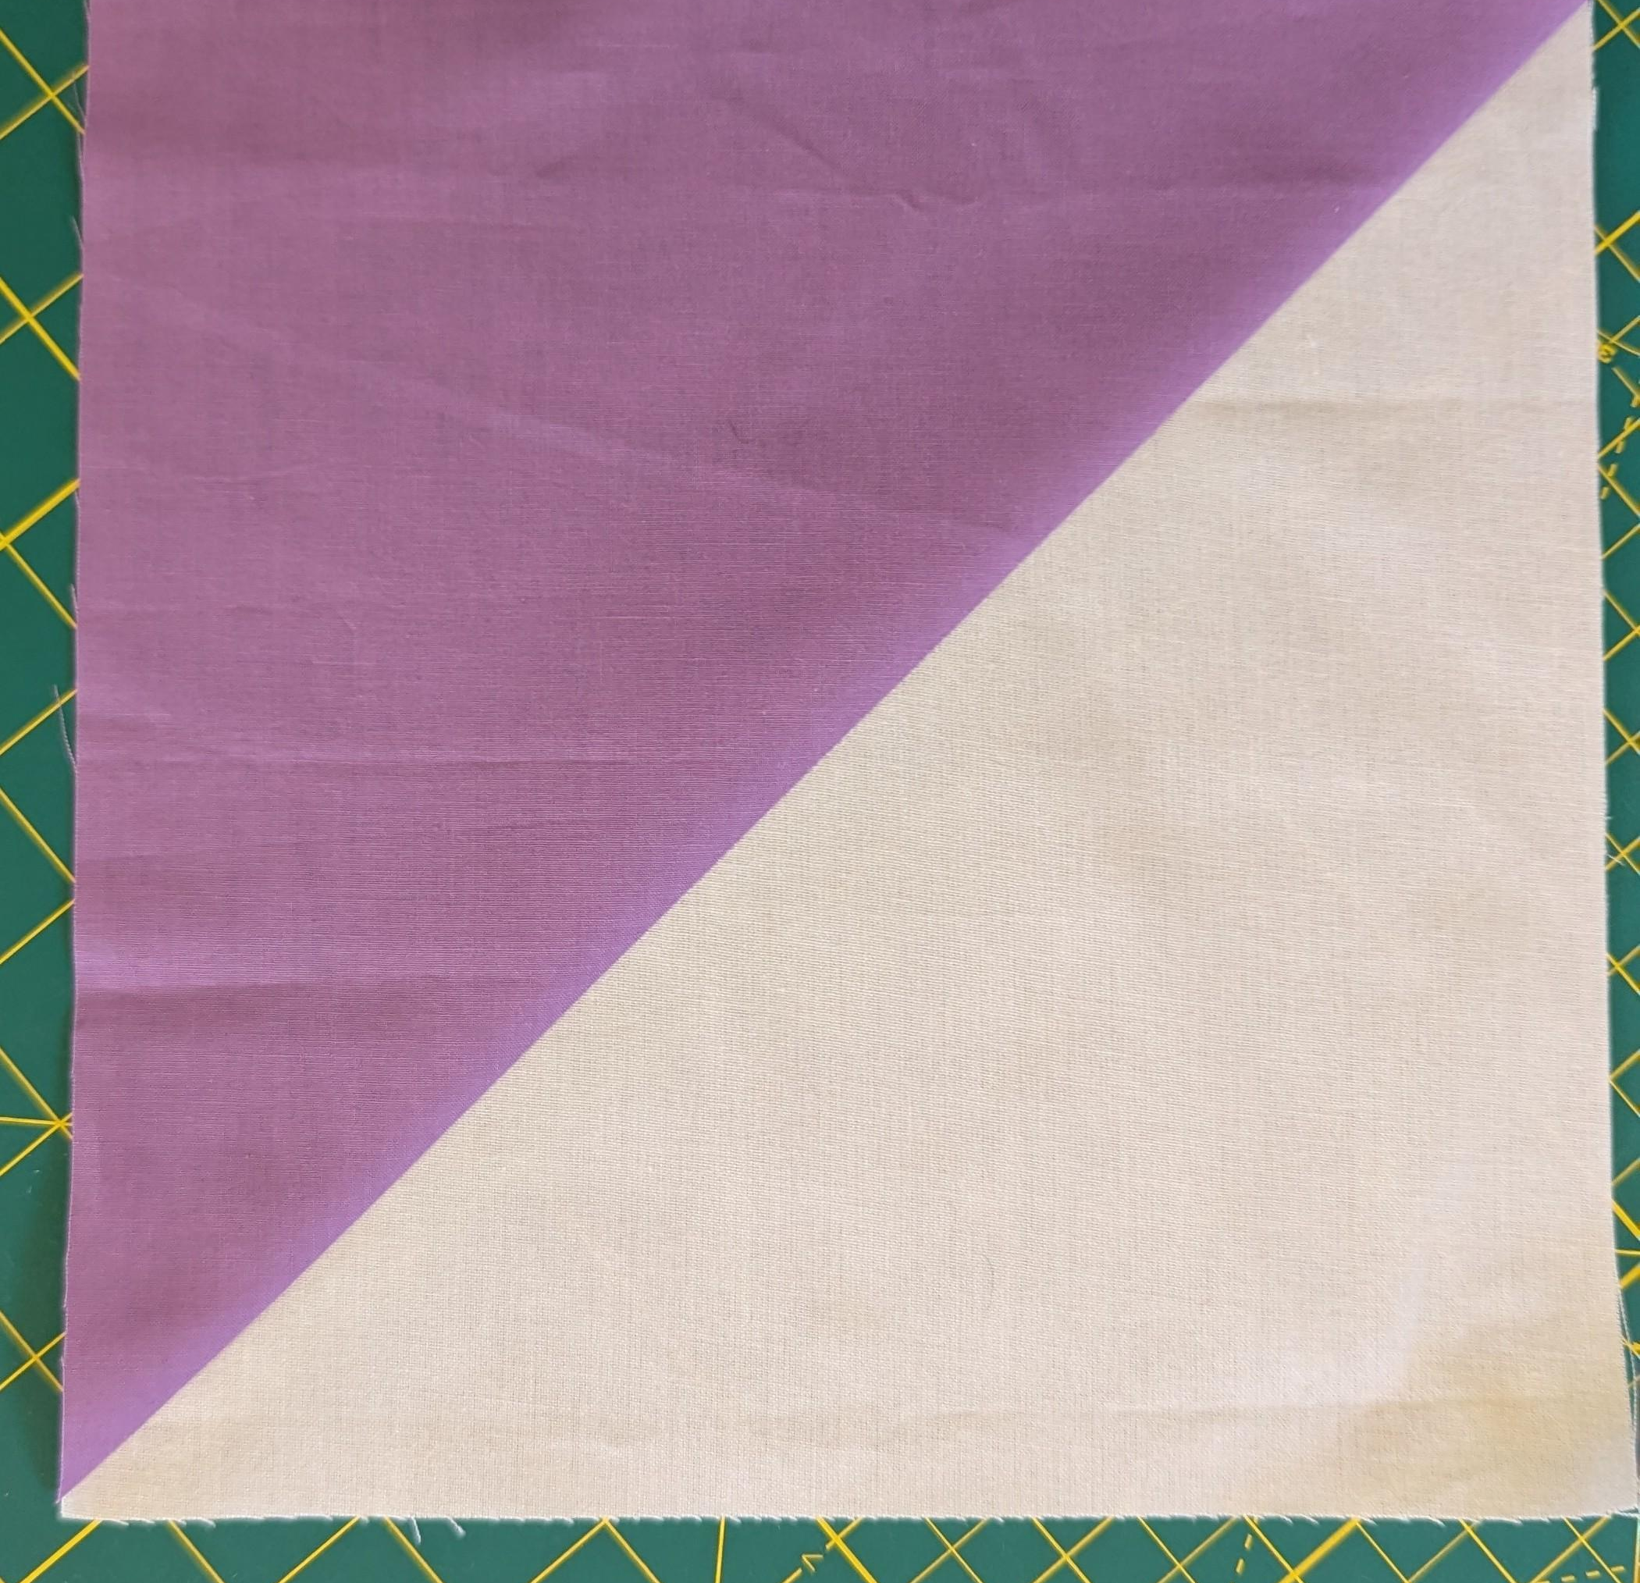
- Cut each block into four strips of two and 3/8” wide. For each block turn the strips 180 degrees. Sew strips together with a ¼” seam allowance.
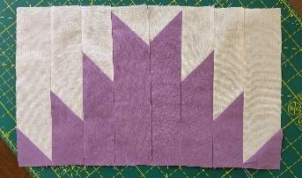
- Blocks will not be square. They are 8” by 9.5” unfinished. You can add strips to the sides of the blocks if you want square blocks.
- For a modern version take fabric and cut into 10.5” long strips. Cut the strips in various widths. I used scrap fabrics. Sew the strips together and cut into a 10.5” square. Use that square with a plain square to make the HST blocks. Follow the directions for the traditional block for making the HST and cutting the HST. You may also design your own version of a modern take on the Delectable Mountain Block.

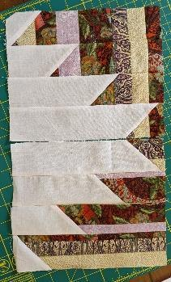
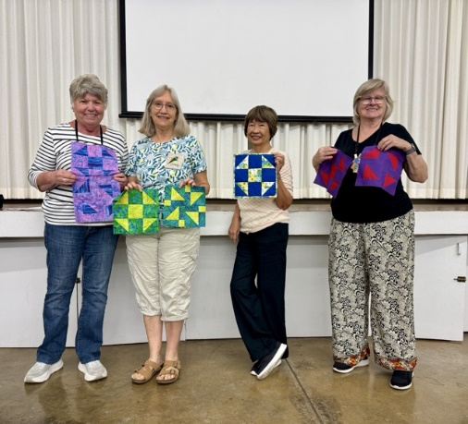 Talented members who made the Shoo Fly Block.

