Wonky Star Tutorial

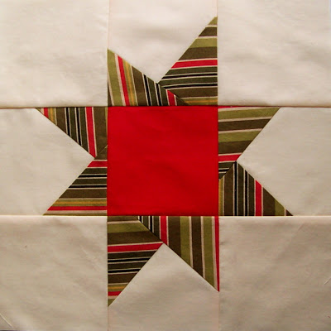

Here's a simply tutorial on how to make a 12.5" wonky star block for the Bushfire Quilt Project, which I blogged about in the previous post. (My apologies for the variations in the lighting of these photos, the clouds kept rolling in and out during this shoot.

UPDATED NOTE: I wrote this tutorial, in an attempt to make the process as straight forward and simple to follow as I possibly could. However, please know that if you use triangle shapes cut a bit larger, ( by an inch or two) you will have more leeway in how you position them and more possibilities in getting your star to be EXTRA wonky!

You will need to start with 13 squares of fabric each cut 4.5"
Out of these 13 squares you should have:
~ 8 white or cream, (these will be for the background)
~ 4 any color/pattern you choose, (these will be for the star points)
~ 1 any color/pattern you choose, (this will be the center of the star)

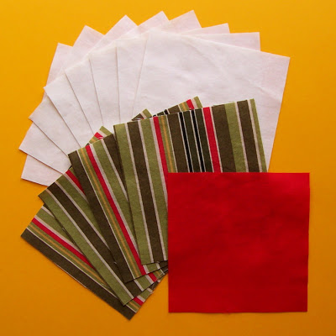

Stack the 4 star point squares and slice in half so you have 8 triangles...

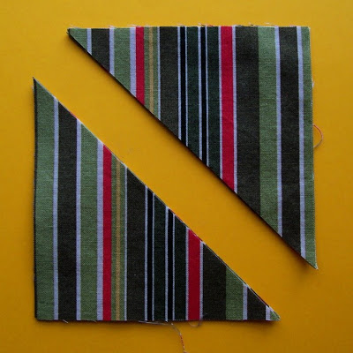

Select 4 of the background squares and 4 of the star point triangles. Stitch one triangle to the right side of each background square. Changing the angle of the triangles will help create the wonky-ness of the star. (Make sure that when the triangle is flipped and ironed to the correct side, it extends past the edges of the background square.)

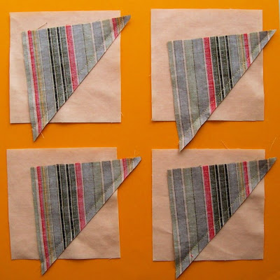

Cut the excess background fabric off...

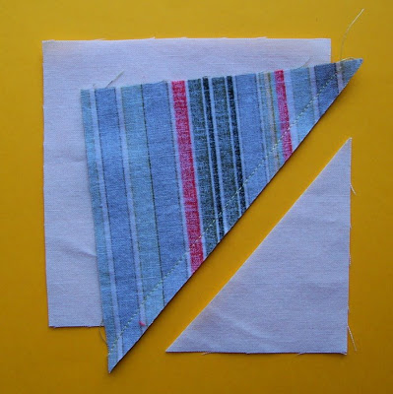

Flip the star point triangle to the right side and press with a hot iron...

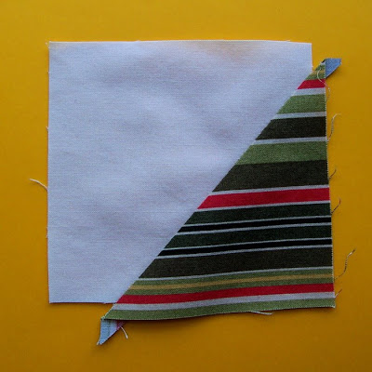

Sew the remaining 4 triangles to the left side of these 4 background blocks. You can overlap the triangles slightly at the bottom, or leave a space. Each variation just adds to the wonky-ness...

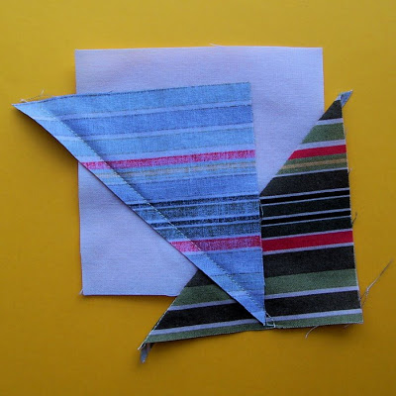

Again, cut off the excess fabric as shown...

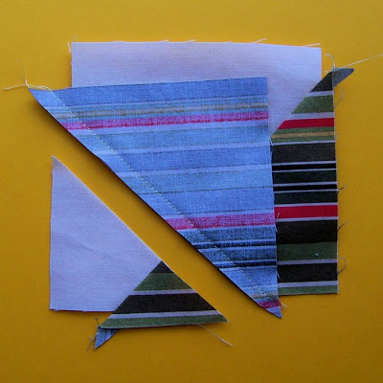

and flip the star point triangle to the left side and press with a hot iron...

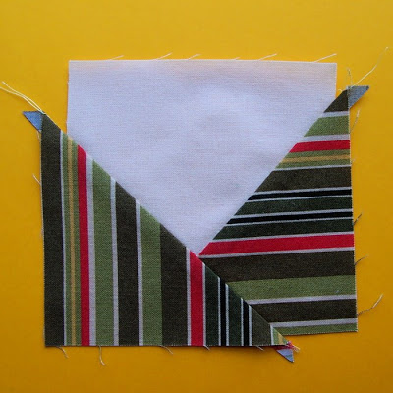

Cut off all excess fabric, making the squares 4.5" again...

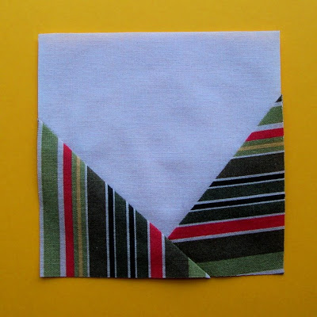

Take your center square and using a scant, (just under) 1/4" seam allowance, stitch a completed star point square to both the left and right side as shown...

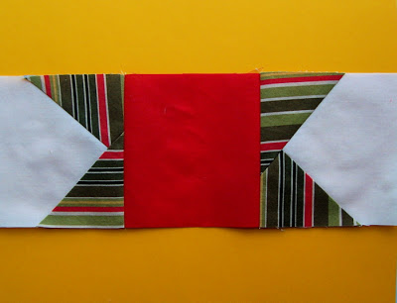

Take one of the remaining star point squares and again using a scant 1/4" seam allowance, sew a plain background square to both the left and right sides. Repeat with the 3 remaining squares...

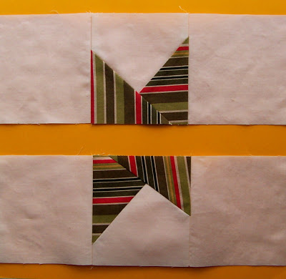

Press and iron all 3 rows. (Because the background is light in color it's best to iron the seams towards the star points. Do this with the center row as well, thus helping to reduce bulk when all three rows are joined together)...

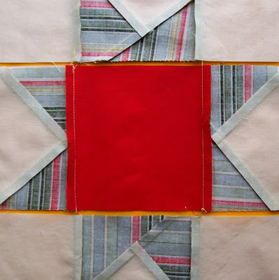

Line up the seams, pin and using a scant 1/4" seam allowance, stitch the top row to the middle row. Repeat with the bottom row...

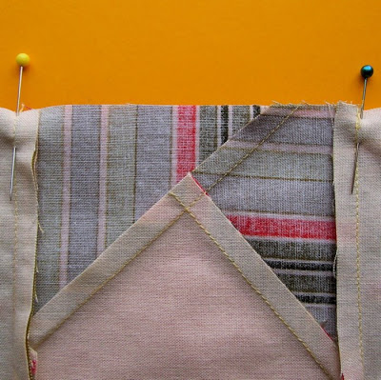

Iron the seams towards the top and bottom rows. Flip to right side and smile at your completed wonky star!...

I would like to note that this technique was first devised by Gwen Marston and shown in her wonderful book Liberated Quiltmaking.

